TRINAMIX INC
Junior AI Engineer — Hiring Task
Build a Supply Chain Chatbot using Flowise

Chat Bot Link : https://cloud.flowiseai.com/chatbot/67490c70-275f-4ad9-addb-7873fe003ce5

Step 1 :
Created a Flowise Cloud account and Created a Document Store.
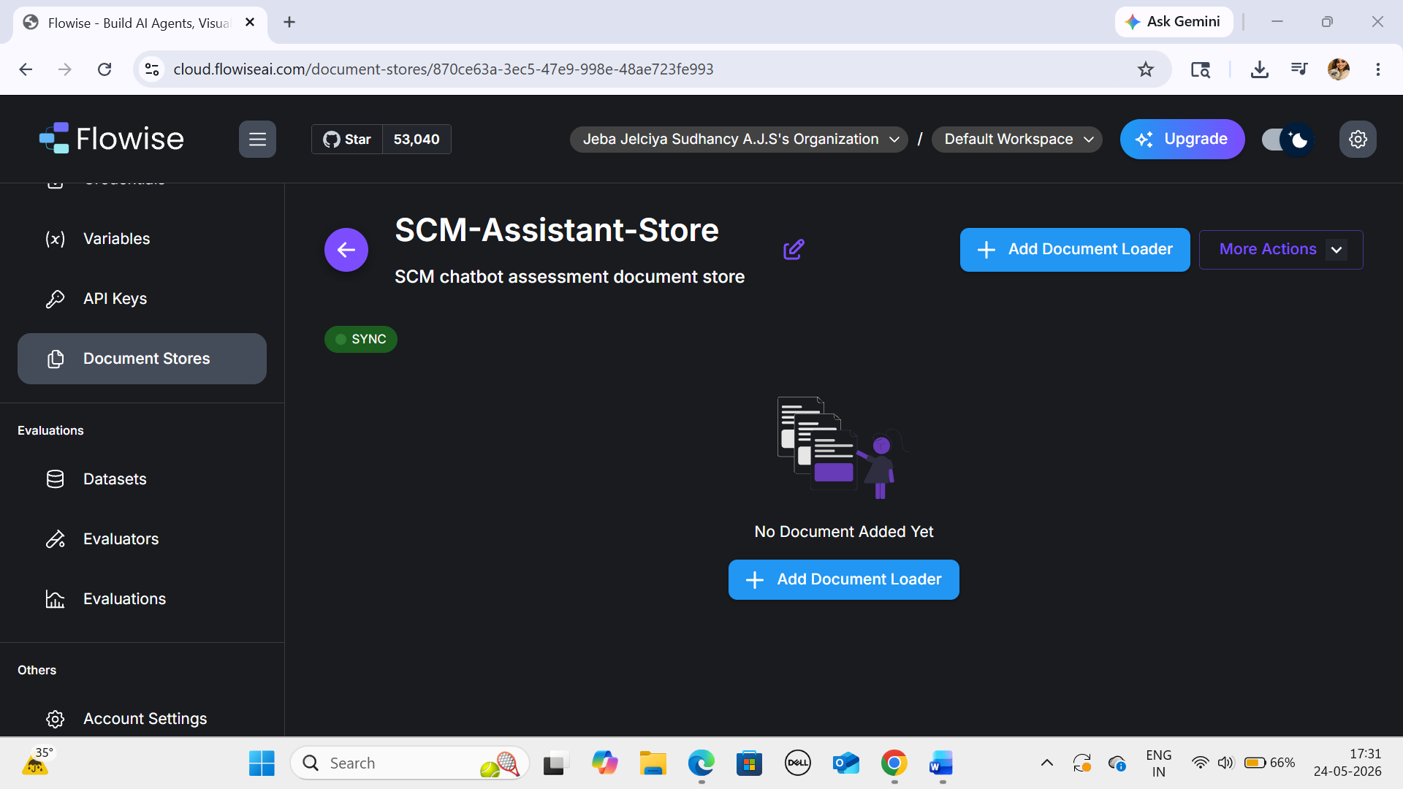

Step 2:
Loaded the data and recorded the chunk count for each file.
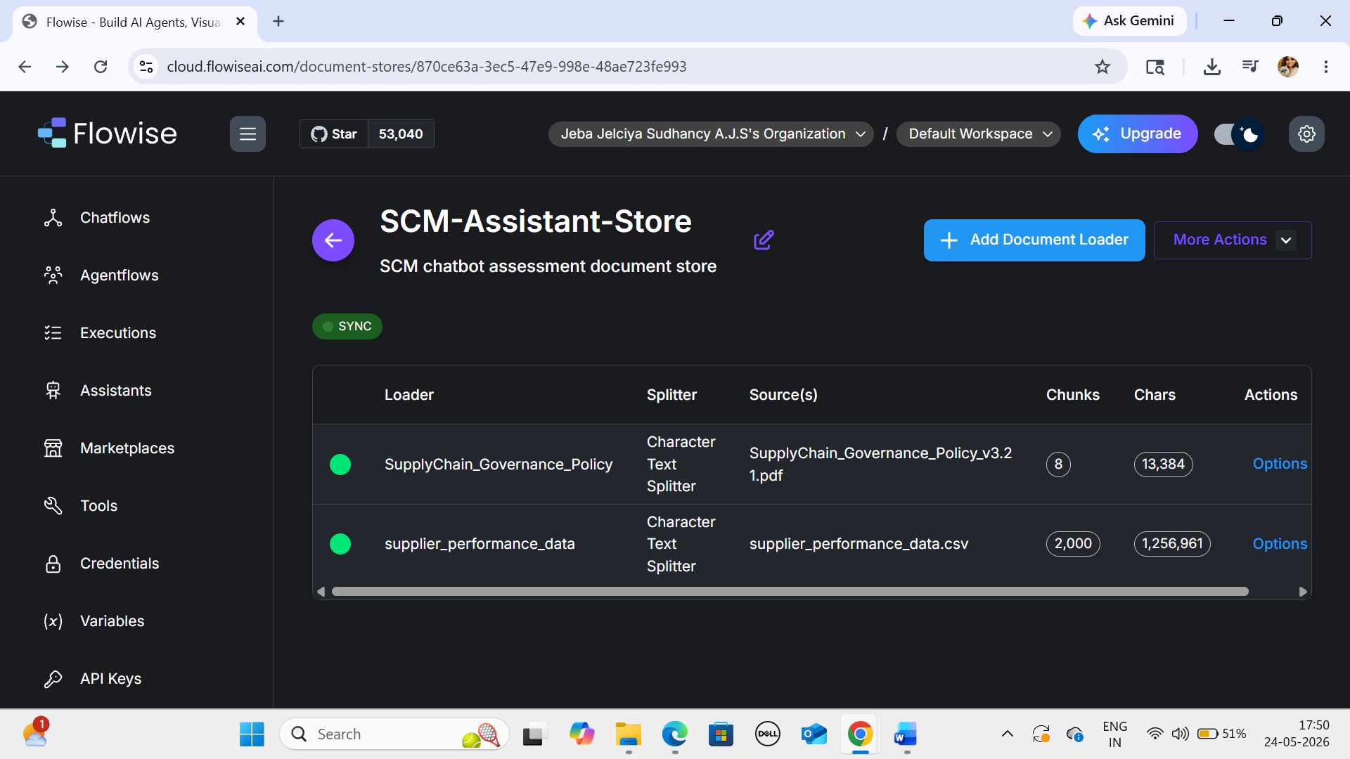
Step 3:
Building the Chatflow / Agent Flow

File Loader:
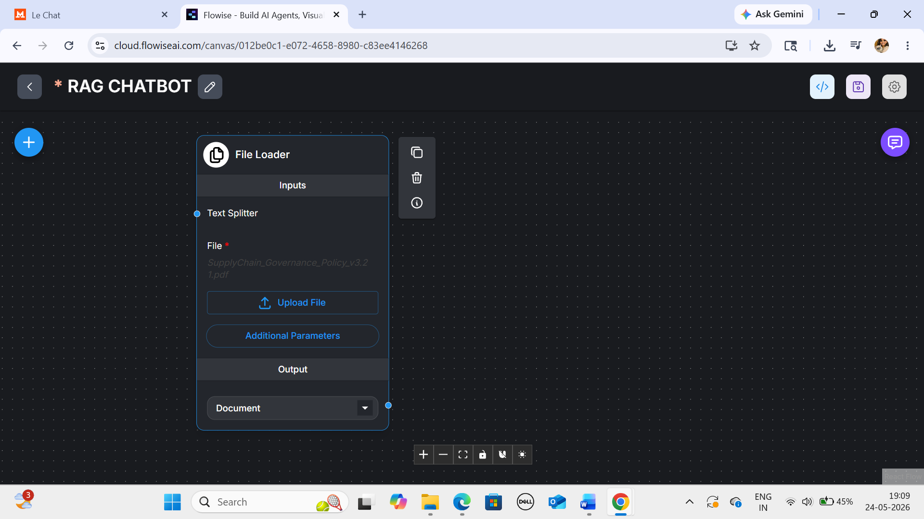

Recursive Character Text Splitter:
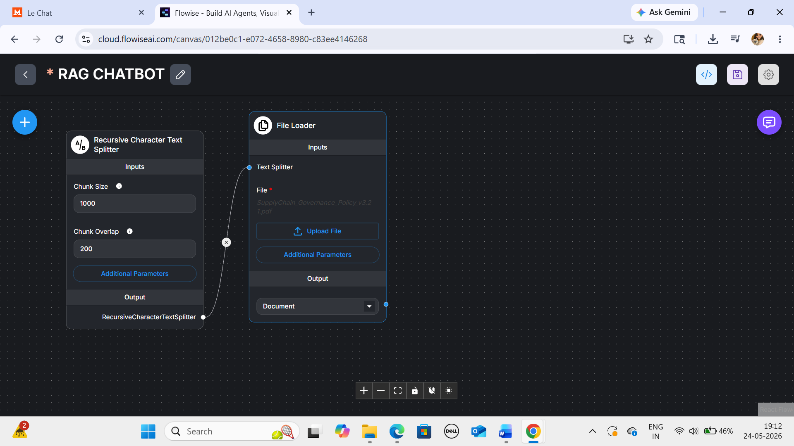

Embedding:
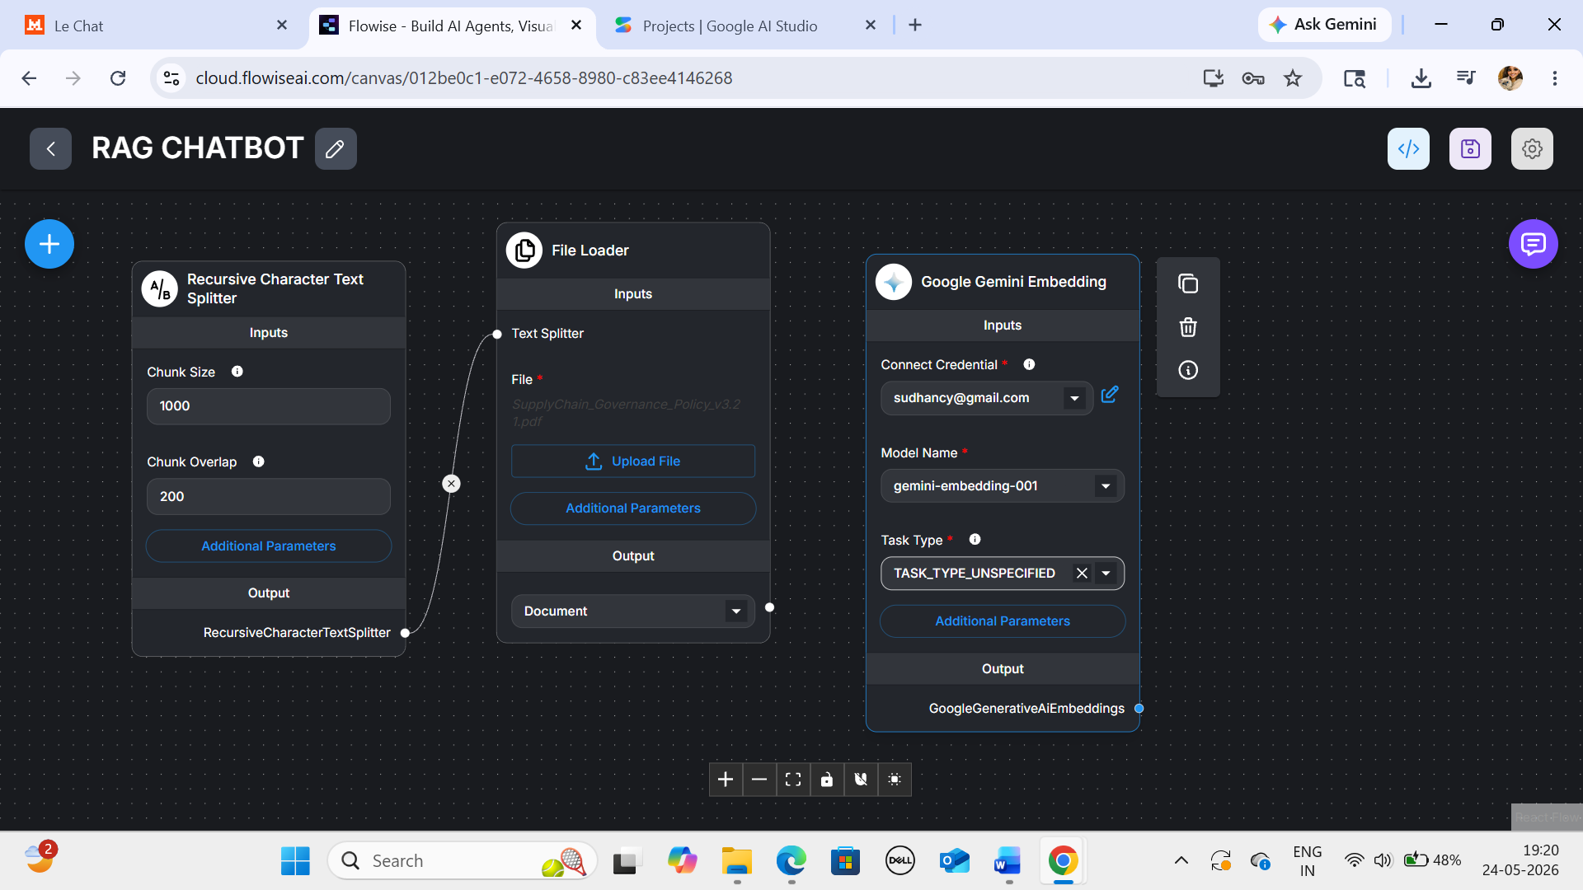

Google Gemini AEmbedding:
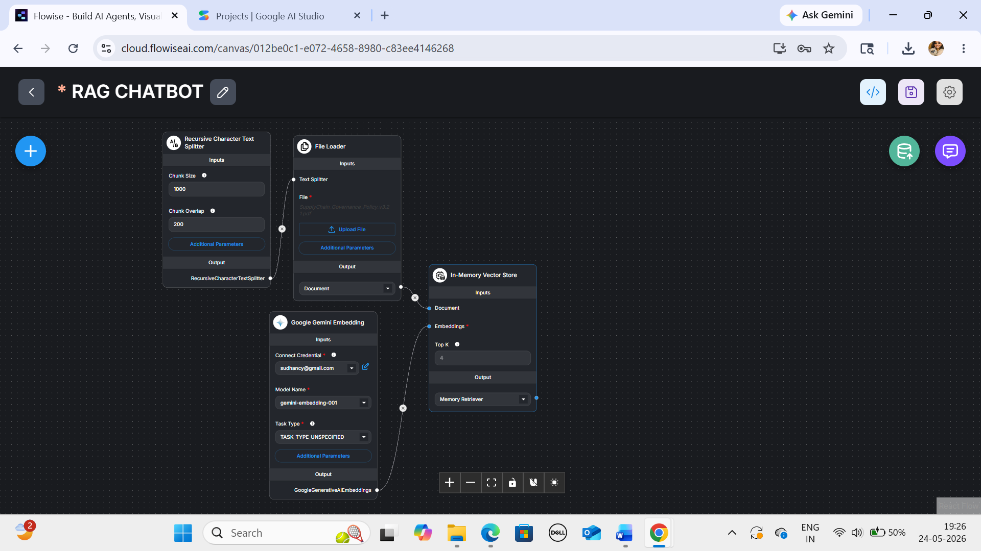

Conversational retrieval QA chain:

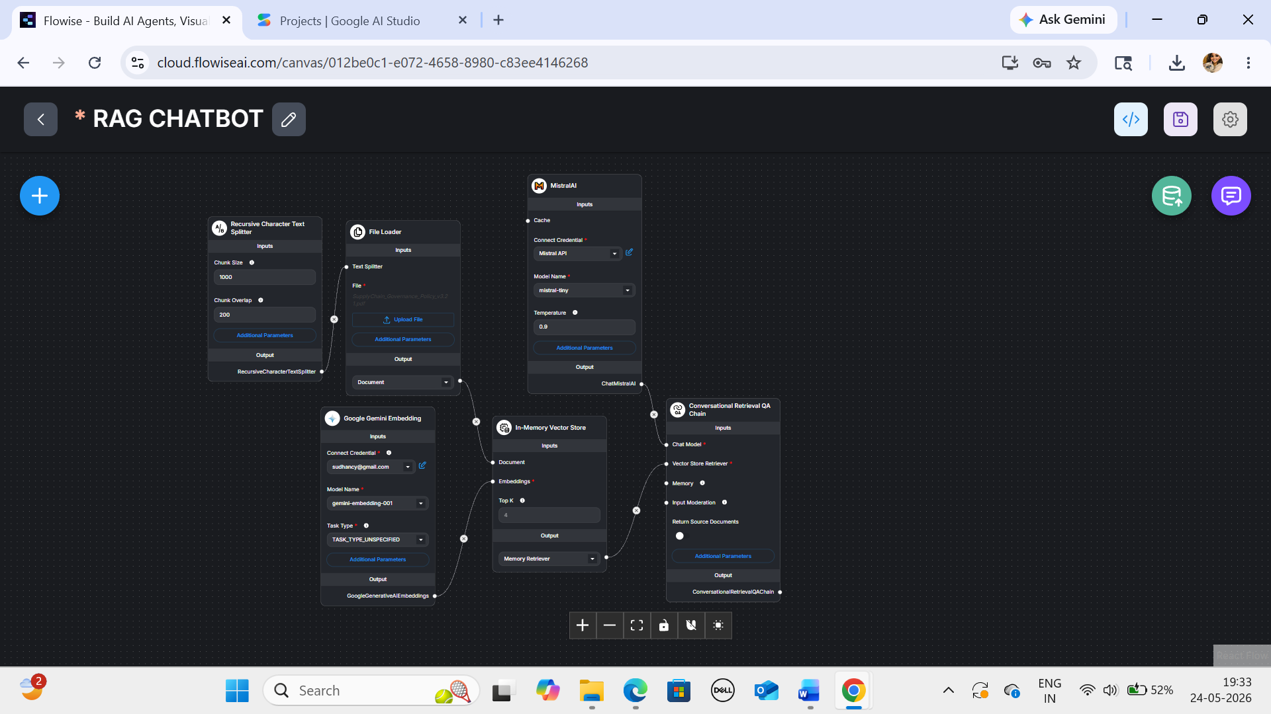

Buffer Memory:

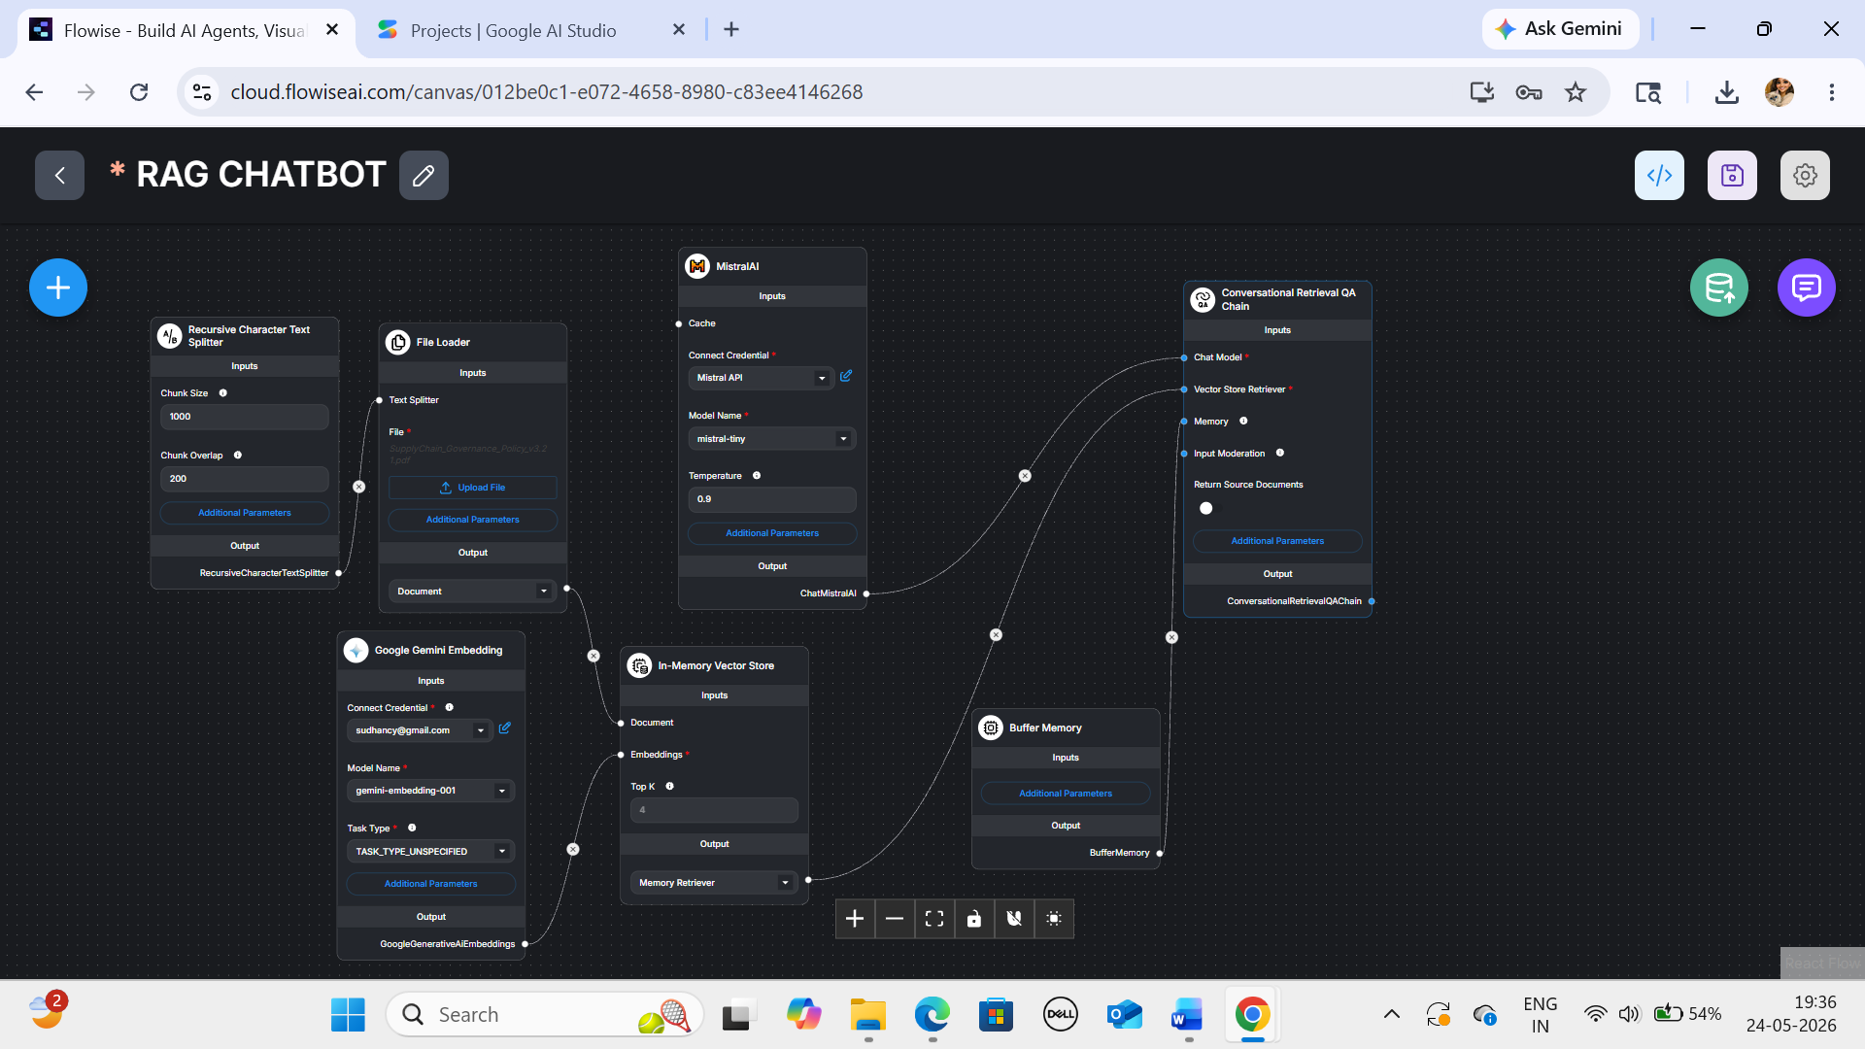

Flowise AICanvas:

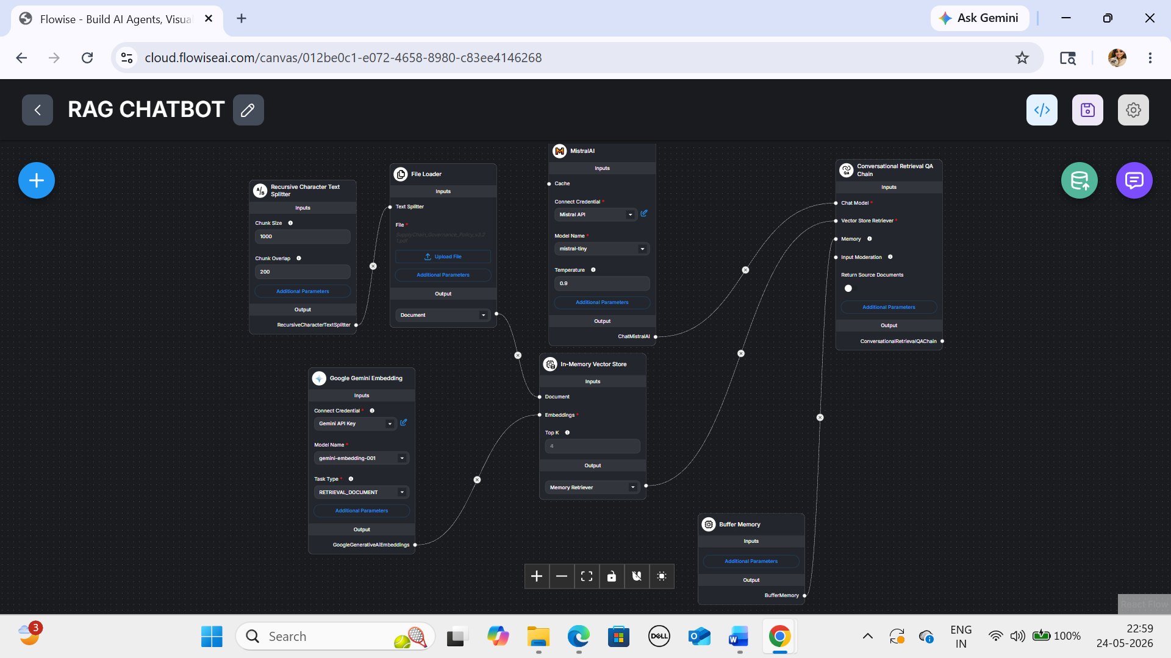

SAMPLE QUESTIONS AND ANSWERS:
Q2:

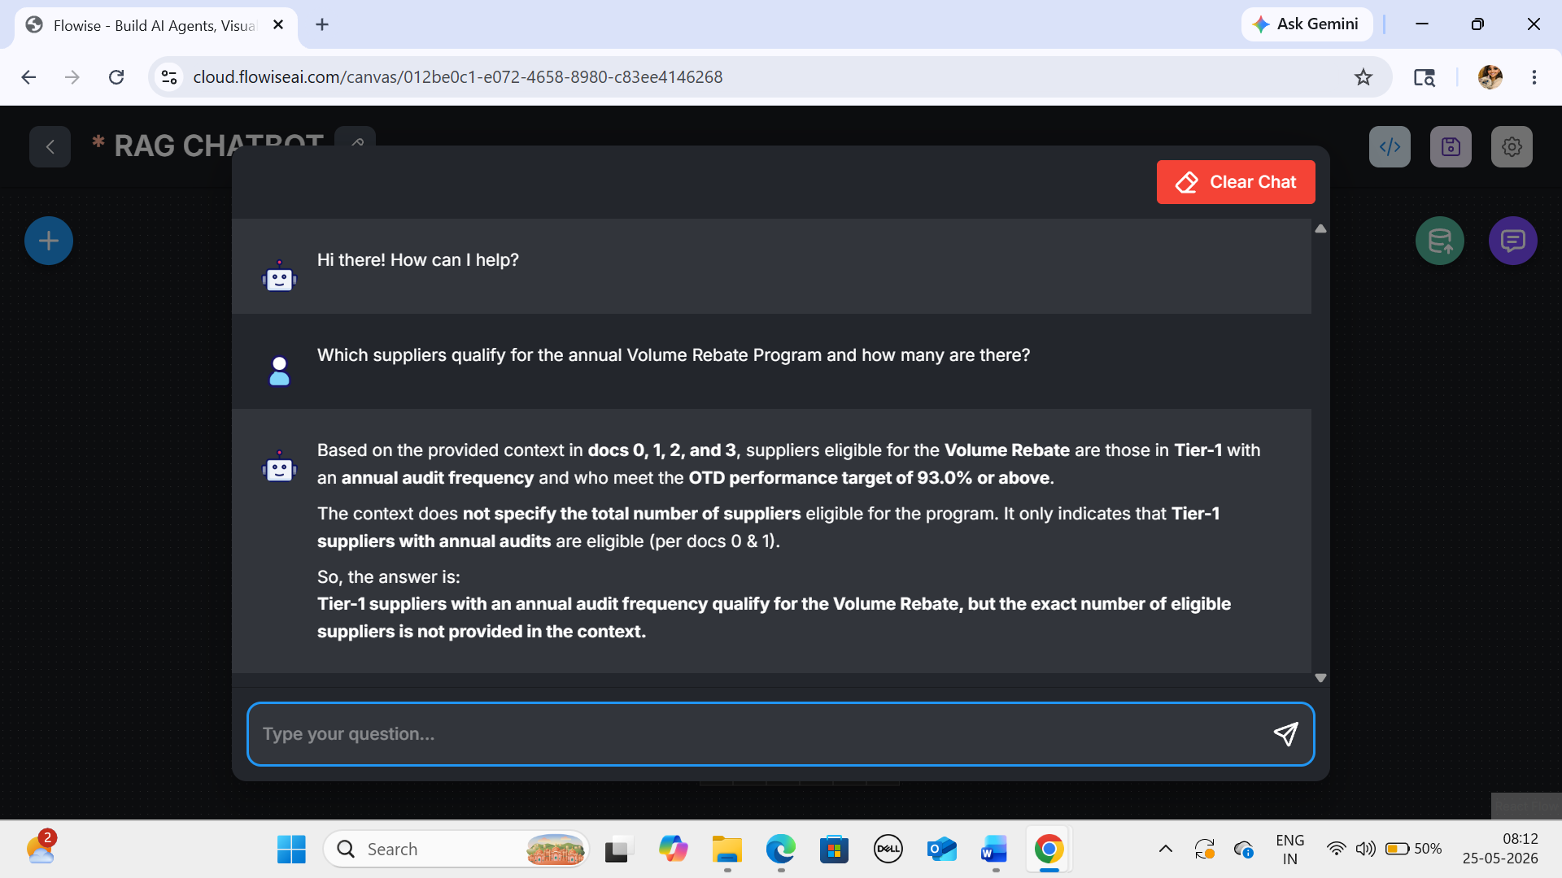

Q5:

